SUBA SOUTH HARVESTING DATA ANALYSIS FOR THE FINANCIAL YEAR 2023-2024



| **DATE** | **NAME** | **ABDP UNIQUE No.** | **SUB-COUNTY** | **ADA** | **GENDER** | **AGE GROUP** | **AREA (M2)** | **SPECIES** | **PIECES** | **WEIGHT(KG)** | **VALUE (Sh)** |
| --- | --- | --- | --- | --- | --- | --- | --- | --- | --- | --- | --- |
| **0** | 12/24/2023 | Steven Onyango Ogalo | 02/SBS/GWS/0904 | S/S | G/S | M | A | 300 | TILAPIA | 940 | 315.000 | 94,500.00 |
| **1** | 10/10/2023 | Elizabeth Adhiambo Odhiambo | 02/SBS/GWS/0934 | S/S | G/S | F | B | 300 | TILAPIA | 600 | 120.000 | 36,000.00 |
| **2** | 11/8/2023 | Stanley Brigyt Onyango | 02/SBS/GWS/0890 | S/S | G/S | M | A | 300 | TILAPIA | 700 | 210.000 | 60,000.00 |
| **3** | 11/8/2023 | Stanley Brigyt Onyango | 02/SBS/GWS/0890 | S/S | G/S | M | A | 300 | CATFISH | 200 | 20.000 | 10,000.00 |
| **4** | 18/2/2024 | VINCENT OTIWA ONACHO | 02/SBS/GWS/0893 | S/S | G/S | M | B | 300 | TILAPIA | 600 | 102.000 | 30,600.00 |
| **5** | 18/2/2024 | VINCENT OTIWA ONACHO | 02/SBS/GWS/0893 | S/S | G/S | M | B | 150 | TILAPIA | 250 | 37.500 | 11,250.00 |
| **6** | 23/11/2023 | CONSLATA ANYANGO NDEJE | 02/SBS/GWN/0907 | S/S | G/S | F | B | 100 | TILAPIA | 525 | 73.500 | 22,050.00 |
| **7** | 22/12/2023 | GERVAS OKEYO IKHAM | 02/SBS/GWN/0908 | S/S | G/S | M | B | 300 | TILAPIA | 800 | 200.000 | 60,000.00 |
| **8** | 22/12/2023 | GERVAS OKEYO IKHAM | 02/SBS/GWN/0908 | S/S | G/S | M | B | 200 | TILAPIA | 450 | 135.000 | 40,500.00 |
| **9** | 23/11/2023 | WILLIAM OKETCH CHALA | 02/SBS/GWN/0882 | S/S | G/S | M | B | 100 | TILAPIA | 800 | 120.000 | 36,000.00 |
| **10** | 11/1/2024 | OBANGA PRIMARY SCHOOL | 02/SBS/GWN/ | S/S | G/N | M | B | 300 | TILAPIA | 700 | 210.000 | 63,000.00 |
| **11** | 13/02/2024 | Dickson Ogutu Ounga | 02/SBS/GWN/0946 | S/S | G/S | M | C | 300 | TILAPIA | 500 | 160.500 | 75,000.00 |
| **12** | 15/01/2024 | Susan Akinyi | 02/SBS/GWN/0914 | S/S | G/N | F | C | 300 | TILAPIA | 300 | 90.000 | 106,800.00 |
| **13** | 5/1/2024 | Fredrick Ogweno | 02/SBS/GWN/0912 | S/S | G/N | M | A | 300 | TILAPIA | 600 | 180.000 | 214,800.00 |
| **14** | 12/2/2024 | Caroline Obambo | 02/SBS/GWN/0908 | S/S | G/N | F | B | 300 | TILAPIA | 500 | 150.000 | 178,800.00 |
| **15** | 10/1/2024 | Euphemiah Anyango | 02/SBS/GWN/0882 | S/S | G/N | F | A | 300 | TILAPIA | 700 | 245.000 | 124,800.00 |
| **16** | 11/12/2023 | Joseph Otieno | 02/SBS/GWN/0916 | S/S | G/N | M | B | 300 | TILAPIA | 420 | 117.600 | 49,000.00 |
| **17** | 7/1/2024 | Samwel Aitila | 02/SBS/GWN/0917 | S/S | G/N | M | B | 300 | TILAPIA | 200 | 116.000 | 56,000.00 |
| **18** | 8/2/2024 | Edys Ogweno | 02/SBS/GWN/0915 | S/S | G/N | M | C | 300 | TILAPIA | 800 | 240.000 | 167,000.00 |
| **19** | 21/01/2024 | Margaret Seya | 02/SBS/GWN/0866 | S/S | G/N | F | C | 300 | TILAPIA | 470 | 94.000 | 18,200.00 |
| **20** | 3/12/2023 | Consolata Anyango | 02/SBS/GWN/0907 | S/S | G/N | F | B | 300 | TILAPIA | 280 | 89.600 | 22,000.00 |
| **21** | 26/12/2023 | DOMNIC KIAGAI | 02/SBS/GWS/0877 | S/S | G/S | M | C | 300 | TILAPIA | 543 | 130.320 | 32500 |
| **22** | 27/11/2023 | NORAH AKETCH | 02/SBS/GWS/0928 | S/S | G/S | F | C | 300 | TILAPIA | 520 | 188.100 | 43000 |
| **23** | 17/01/2023 | MONICA AKINYI | 02/SBS/GWS/0884 | S/S | G/S | F | B | 300 | TILAPIA | 400 | 200.000 | 50000 |
| **24** | 7/9/2023 | ROSELINE AYAH | 02/SBS/GWS/0874 | S/S | G/S | F | A | 150 | TILAPIA | 320 | 122.000 | 17200 |
| **25** | 23/10/2023 | LENCER ABICH | 02/SBS/GWS/0905 | S/S | G/S | F | A | 180 | TILAPIA | 98 | 30.000 | 7000 |
| **26** | 23/10/2023 | KILIOPA ABICH | 02/SBS/GWS/0869 | S/S | G/S | M | B | 300 | TILAPIA | 150 | 52.500 | 14000 |
| **27** | 27/12/2023 | MARTIN OFUNJO | 02/SBS/GWS/0888 | S/S | G/S | M | C | 300 | TILAPIA | 670 | 147.400 | 36850 |
| **28** | 24/12/2023 | PHILIP OKOTH | NaN | S/S | G/N | M | B | 300 | TILAPIA | 356 | 100.392 | 25098 |
| **29** | 24/12/2023 | PAMELA ATOTO | 02/SBS/GWS/0926 | S/S | G/S | F | B | 300 | TILAPIA | 200 | 60.000 | 12000 |
| **30** | 24/12/2023 | LUDIA AOKO | 02/SBS/GWS/0935 | S/S | G/S | F | B | 300 | TILAPIA | 320 | 91.000 | 18500 |
| **31** | 21/10/2023 | LEWNIDA AWUOR | 02/SBS/GWS/0911 | S/S | G/S | F | B | 300 | TILAPIA | 300 | 95.000 | 19600 |
| **32** | 24/11/2023 | FRED OTIENO | 02/SBS/GWS/0900 | S/S | G/S | M | B | 300 | TILAPIA | 310 | 90.500 | 17400 |
| **33** | 4/11/2023 | JACK ODHIAMBO | 02/SBS/GWS/0901 | S/S | G/S | M | B | 300 | TILAPIA | 210 | 55.000 | 11000 |
| **34** | 2/12/2023 | PHILEMOM OWESO | 02/SBS/GWS/0856 | S/S | G/S | M | B | 300 | TILAPIA | 530 | 151.320 | 33000 |
| **35** | 24/11/2023 | KILIOPA OKEYO | 02/SBS/GWS/0892 | S/S | G/S | M | B | 300 | TILAPIA | 490 | 144.000 | 29000 |
| **36** | 23/09/2023 | AMOS JUNGA | 02/SBS/GWS/0872 | S/S | G/S | M | B | 300 | TILAPIA | 320 | 88.000 | 19000 |
| **37** | 13/10/2023 | ELIZABETH ADHIAMBO | 02/SBS/GWS/0934 | S/S | G/S | F | B | 300 | TILAPIA | 190 | 48.000 | 8800 |
| **38** | 20/09/2023 | GETRUDA AWINO | 02/SBS/GWS/0873 | S/S | G/S | F | B | 300 | TILAPIA | 310 | 91.000 | 22000 |
| **39** | 11/11/2023 | JOCINTER OMUGA | 02/SBS/GWS/0857 | S/s | G/N | F | B | 300 | TILAPIA | 409 | 88.000 | 17200 |
| **40** | 9/10/2023 | MONICA OKUMU | 02/SBS/GWS/0909 | S/S | G/S | F | B | 300 | TILAPIA | 224 | 46.000 | 9500 |
| **41** | 26/12/2023 | Domnic Kiagai | 02/SBS/GWS/0877 | S/S | G/N | M | B | 300 | TILAPIA | 543 | 130.320 | 32500 |
| **42** | 27/12/2023 | Martin Ofunjo | 02/SBS/GWS/0888 | S/S | G/N | M | B | 300 | TILAPIA | 670 | 147.400 | 36850 |
| **43** | 24/12/2023 | Okoth makwaro | NaN | S/s | G/N | M | B | 300 | TILAPIA | 356 | 100.392 | 25098 |
| **44** | 24/10/2023 | Lilian Achieng Gor | 02/SBS/GWS/0928 | S/s | G/S | M | B | 300 | TILAPIA | 670 | 187.600 | 95,670 |
| **45** | 24/10/2023 | Joshua Olewe Omiti | 02/SBS/GWS/0887 | S/s | G/S | M | C | 300 | TILAPIA | 700 | 126.000 | 70,000 |
| **46** | 8/10/2023 | Jeremiah Ogwedhi Mwabe | 02/SBS/GWS/0936 | S/s | G/S | M | A | 300 | TILAPIA | 150 | 30.000 | 10,000 |
| **47** | 5/10/2023 | Monica Akinyi Otieno | 02/SBS/GWS/0884 | S/s | G/S | F | B | 300 | TILAPIA | 500 | 80.000 | 50,000 |
| **48** | 22/10/2023 | Wilson Onjiko Maganga | 02/SBS/GWS/0875 | S/s | G/S | M | B | 300 | TILAPIA | 800 | 200.000 | 200,000 |
| **49** | 22/9/2023 | Christopher Olwese | 02/SBS/GWS/0895 | S/s | G/S | M | B | 300 | TILAPIA | 670 | 187.600 | 95,670 |

· **Dates and Names**: Each row lists the date when the harvesting was done and the name of the person or entity responsible for the fishing.

· **Unique IDs and Locations**: Each record has a unique identification number and specifies the sub-county where the fishing took place.

· **Gender and Age Group**: The gender of the person involved in fishing and their age group are recorded.

· **Fishing Area**: The area (in square meters) where the fishing was conducted.

· **Species of Fish**: The type of fish caught, mainly Tilapia and occasionally Catfish.

· **Quantity and Weight**: The number of fish caught and their total weight in kilograms.

· **Value**: The monetary value of the fish caught, given in Kenyan Shillings (Sh).

| **index** | **AREA (M2)** | **PIECES** | **WEIGHT(KG)** |
| --- | --- | --- | --- |
| **count** | 50.0 | 50.0 | 50.0 |
| **mean** | 281.6 | 465.28 | 124.67088 |
| **std** | 51.99529021057226 | 210.3195857814134 | 62.99706156562918 |
| **min** | 100.0 | 98.0 | 20.0 |
| **25%** | 300.0 | 302.5 | 88.4 |
| **50%** | 300.0 | 480.0 | 118.8 |
| **75%** | 300.0 | 652.5 | 158.20499999999998 |
| **max** | 300.0 | 940.0 | 315.0 |
|  |  |  |  |

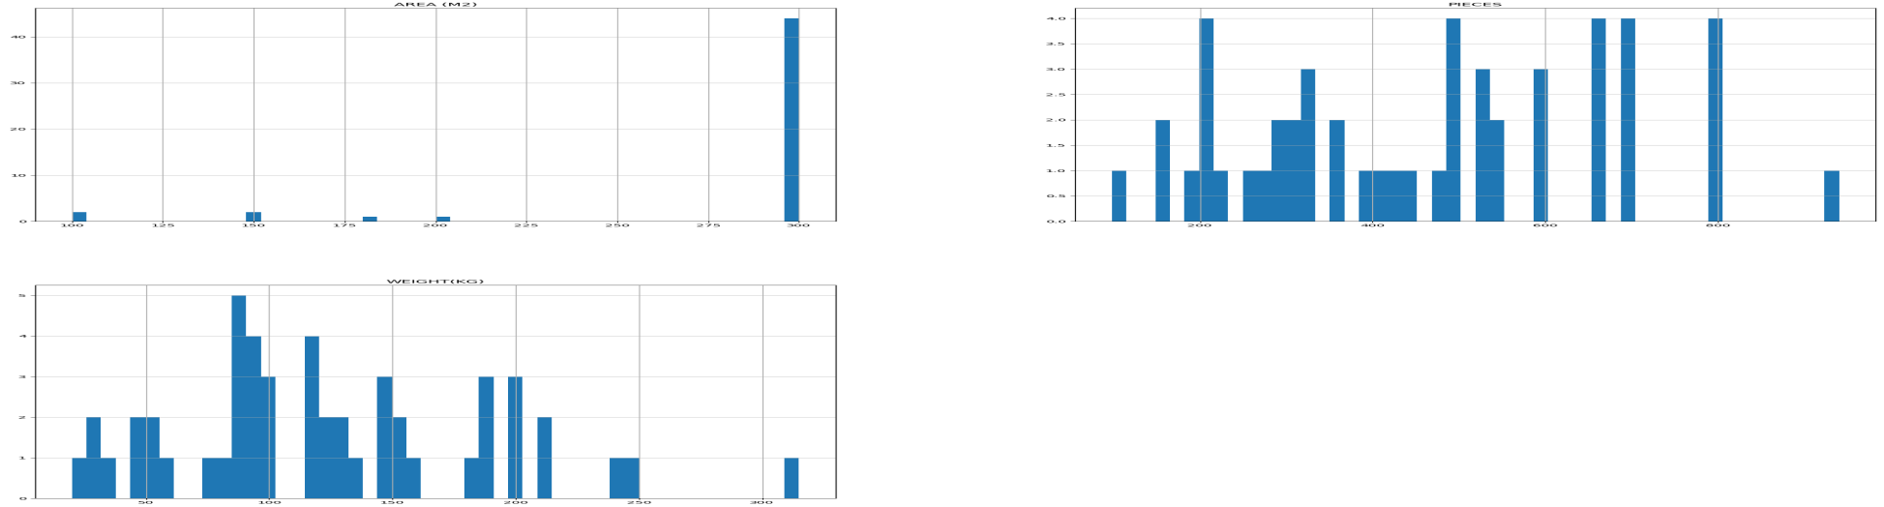

* **Total Records (count)**: There are 50 entries in the dataset, each representing a fishing activity.

· **Average (mean)**:

* **Area (M2)**: The average size of the fishing area used is 281.6 square meters.
* **Pieces**: On average, 465.28 fish were caught per entry.
* **Weight (KG)**: The average weight of the fish caught per entry is 124.67 kilograms.

· **Variation (std)**:

* **Area (M2)**: The standard deviation is about 52 square meters, indicating how much the area sizes vary from the average.
* **Pieces**: The standard deviation is about 210 fish, showing variability in the number of fish caught.
* **Weight (KG)**: The standard deviation is about 63 kilograms, indicating variability in the total weight of the fish caught.

· **Minimum (min)**:

* **Area (M2)**: The smallest fishing area used is 100 square meters.
* **Pieces**: The fewest fish caught in a single entry is 98.
* **Weight (KG)**: The lightest total catch weight recorded is 20 kilograms.

· **First Quartile (25%)**:

* **Area (M2)**: 25% of the fishing activities used exactly 300 square meters.
* **Pieces**: 25% of the entries caught up to 302.5 fish.
* **Weight (KG)**: 25% of the entries had a total catch weight up to 88.4 kilograms.

· **Median (50%)**:

* **Area (M2)**: Half of the entries used 300 square meters.
* **Pieces**: Half of the entries caught up to 480 fish.
* **Weight (KG)**: Half of the entries had a total catch weight up to 118.8 kilograms.

· **Third Quartile (75%)**:

* **Area (M2)**: 75% of the entries used exactly 300 square meters.
* **Pieces**: 75% of the entries caught up to 652.5 fish.
* **Weight (KG)**: 75% of the entries had a total catch weight up to 158.21 kilograms.

· **Maximum (max)**:

* **Area (M2)**: The largest fishing area used is 300 square meters (indicating most fishing areas were consistently 300 square meters).
* **Pieces**: The maximum number of fish caught in a single entry is 940.

**Weight (KG)**: The heaviest total catch weight recorded is 315 kilograms.

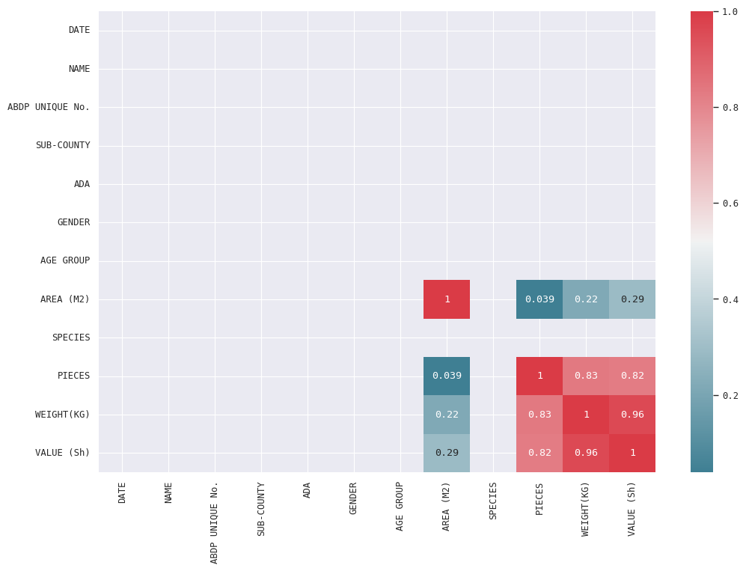

* **PIECES and WEIGHT (0.83)**: There is a strong positive correlation between the number of pieces of fish and their total weight.
* **PIECES and VALUE (0.82)**: There is also a strong positive correlation between the number of pieces of fish and their value in Shillings.
* **WEIGHT and VALUE (0.96)**: The weight of the fish is very strongly correlated with their value. This means as the weight increases, the value also increases almost proportionally.
* **AREA (M2) and VALUE (0.29)**: There is a moderate positive correlation between the area and the value, indicating that larger areas might lead to higher values.
* **AREA (M2) and PIECES (0.22)**: There is a weak positive correlation between the area and the number of pieces of fish.
* **Other variables**: The rest of the variables show low or no significant correlation with each other, indicating that they don't have a linear relationship

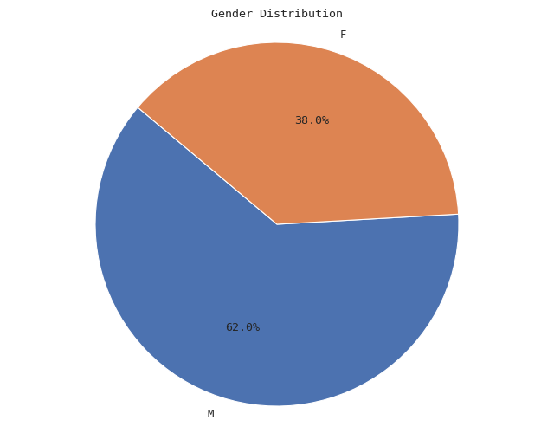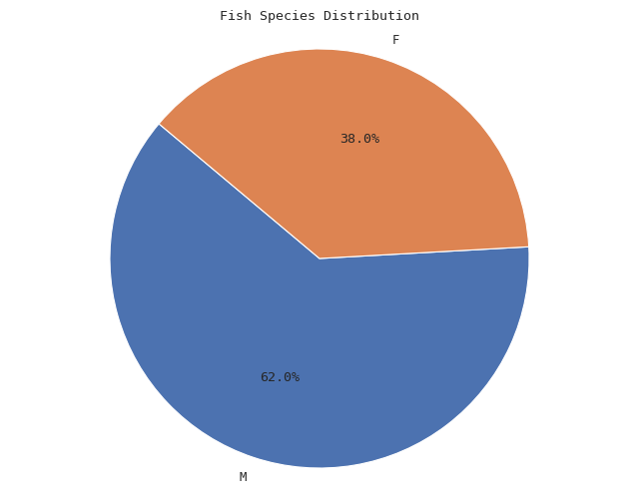

### Gender Distribution

* **Male (M)**: 62%
* **Female (F)**: 38%

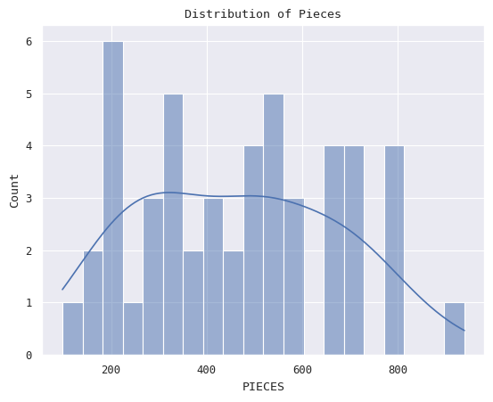

**Histogram Bars**: Each bar on the chart shows us how many puzzles have a certain number of pieces. For example, one bar might show us that 10 puzzles have around 50 pieces each.

**Smooth Curve (KDE)**: This is a line that goes along the tops of the bars. It helps us see the overall pattern of the puzzle pieces without the bumps of the bars. It's like smoothing out the chart so we can see how the number of pieces is spread out more clearly.

**Title**: This tells us what the chart is about. In this case, it tells us that we're looking at how many puzzles have different numbers of pieces.

**What We Learn**: By looking at this chart, we can see if most puzzles have fewer pieces or more pieces, and if there are any puzzles that are very different from the others in terms of how many pieces they have.

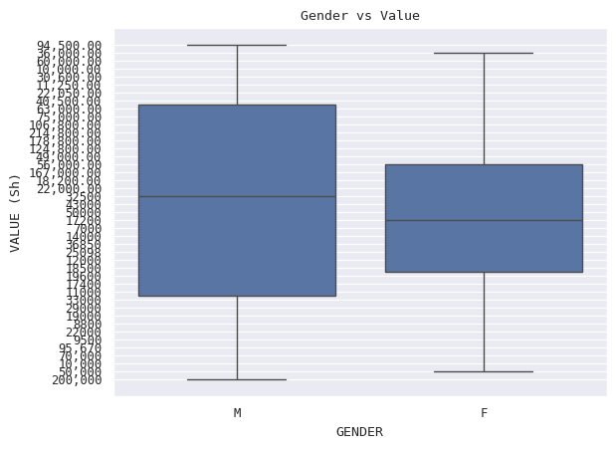

SPECIES PIECES WEIGHT(KG) \

0 CATFISH 200 20.00000

1 TILAPIA 23064 126.80702

VALUE (Sh)

0 10,000.00

1 94,500.0036,000.0060,000.0030,600.0011,250.002...

· **SPECIES**: This column lists different types of fish species, such as 'CATFISH' and 'TILAPIA'.

* **PIECES**: This column likely represents the number of individual fish of each species. For example, there are 200 pieces of 'CATFISH' and 23,064 pieces of 'TILAPIA'.

· **WEIGHT(KG)**: This column shows the total weight in kilograms of each species. For instance, 'CATFISH' weighs 20.00000 kilograms, and 'TILAPIA' weighs 126.80702 kilograms.

* **VALUE (Sh)**: This column appears to contain monetary values in an unclear format. It possibly represents the value of the fish species in a certain currency ('Sh'). The values are separated by commas, indicating different transactions or values associated with the species.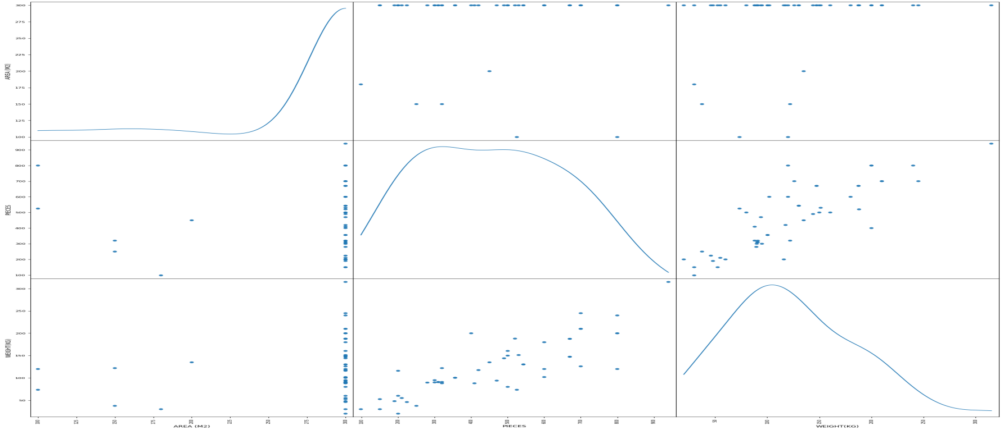

### Brief Summary of the Data

The data contains detailed information about fish transactions, including dates, names of individuals involved, unique transaction identifiers, sub-county locations, gender, age groups, area in square meters, fish species, quantities (pieces), weights in kilograms, and monetary values in Shillings. Each entry represents a transaction where fish (primarily 'TILAPIA' and 'CATFISH') were bought or sold.

**Transaction Details**:

* 1. Transactions occurred across different dates and involved various individuals or entities.
  2. 'TILAPIA' is the predominant fish species in the transactions, with varying quantities and weights.
  3. 'CATFISH' is also involved but to a lesser extent compared to 'TILAPIA'.

**Economic Aspects**:

* 1. The monetary values ('VALUE (Sh)') associated with transactions vary widely, reflecting different transaction sizes and economic implications.
  2. Transactions range from small values (e.g., 7,000 Sh) to substantial amounts (e.g., 214,800 Sh).

**Demographic and Geographical Factors**:

* 1. Gender and age group demographics show involvement from both genders across different age ranges.
  2. Transactions span multiple sub-counties, indicating a broad geographical distribution of fish trading activities.

**Data Quality and Further Analysis**:

* 1. There are instances of missing data (e.g., 'NaN' values in 'ABDP UNIQUE No.'), which may require further cleaning for comprehensive analysis.
  2. Analysis can be expanded to examine temporal trends in transaction volumes and values, seasonal variations, and correlations between quantities, weights, and values.

### Conclusion:

This dataset provides valuable insights into the dynamics of fish transactions within the specified region and timeframe. It highlights the importance of 'TILAPIA' as a key species in local commerce, with transactions varying in scale and economic significance. The involvement of diverse demographic groups and geographic locations underscores the widespread nature of fish trading activities.

Further analysis could focus on exploring correlations between transaction quantities, weights, and values, as well as identifying factors influencing transaction sizes and patterns over time. Cleaning and preparing the data for more detailed statistical analysis and visualization would enhance understanding and decision-making related to fish trading and related economic activities.